Task 1: Packet identification
- Open the PCAP file and identify the total number of packets captured.
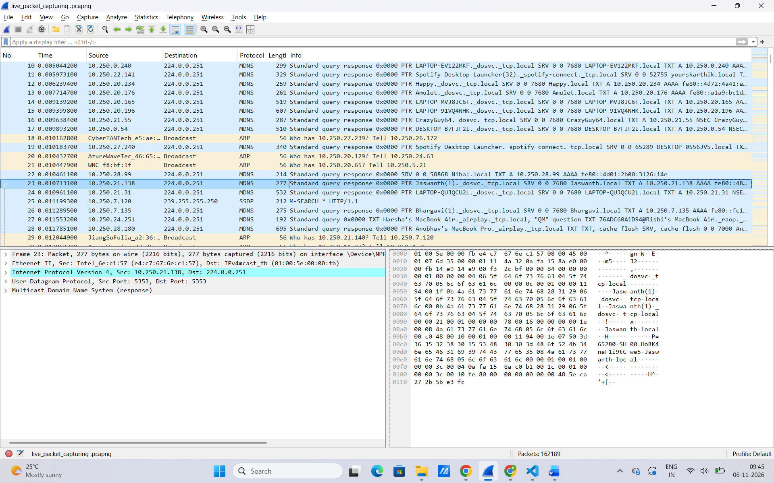
- Apply the filter tcp and record the number of TCP packets.
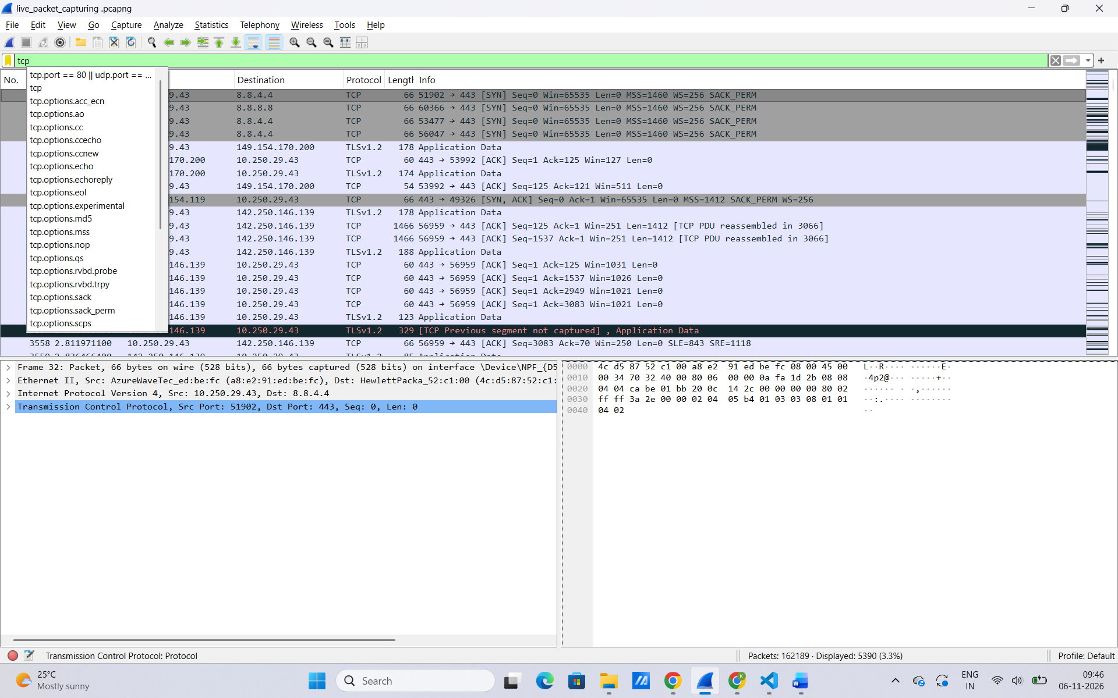
- Apply the filter udp and record the number of UDP packets.
- Apply the filter icmp and record the number of ICMP packets.

- Identify the top five protocols using Statistics → Protocol Hierarchy.
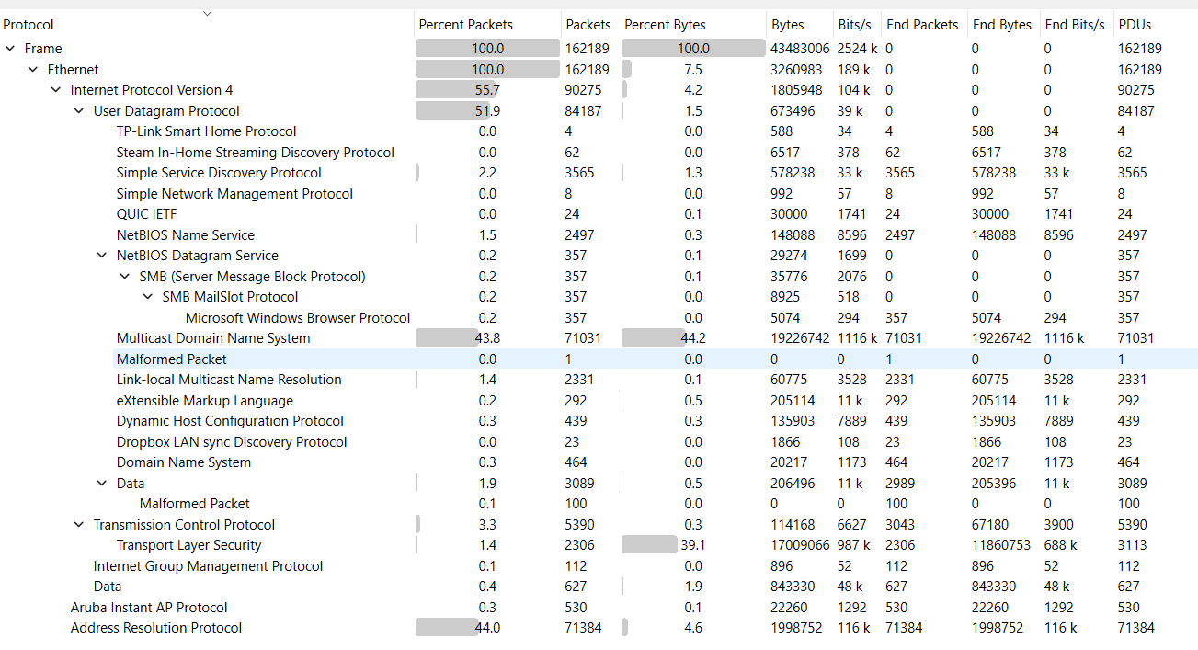

Task 2: Ethernet frame inspection
- Apply the filter eth.
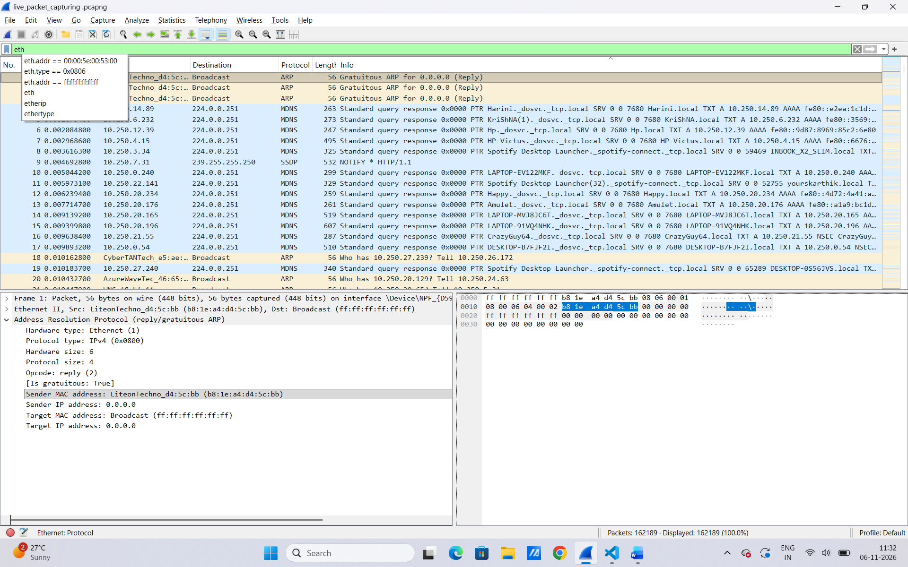
- Select five different packets and record their:
  - Frame number
  - Frame length
  - Source MAC address
  - Destination MAC address
  - EtherType
- Identify packets carrying IPv4 and IPv6 traffic.

Task 3: IPv4 packet inspection
- Apply the filter ip.
- Identify five IPv4 packets and record:
  - Source IP address
  - Destination IP address
  - Header length
  - Total length
  - TTL
  - Identification field
- Find the packet with the maximum IPv4 total length.
- Identify packets with different TTL values.
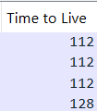

Task 4: TCP header inspection
- Apply the filter tcp.
- Select five TCP packets and record:

  - Source port
  - Destination port
  - Sequence number
  - Acknowledgement number
  - TCP header length
  - Payload length

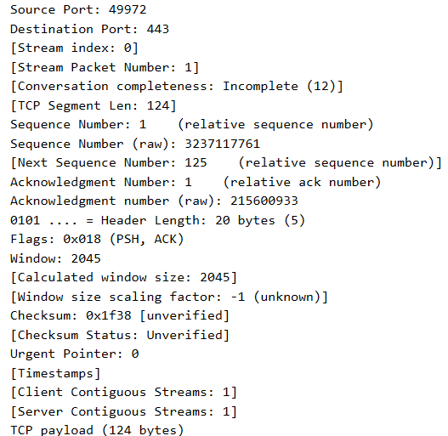

- Apply the filter tcp.flags.syn == 1 and identify TCP connection establishment packets.

- Apply the filter tcp.flags.fin == 1 and identify connection termination packets.
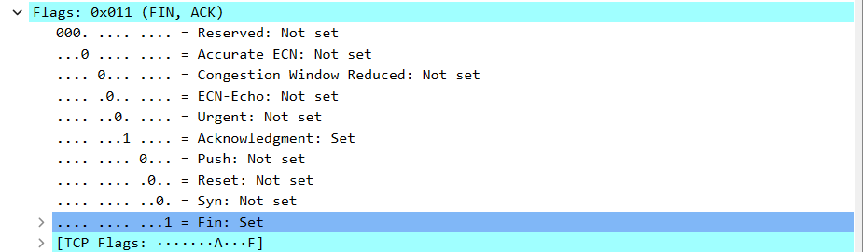

- Identify packets containing TCP options.
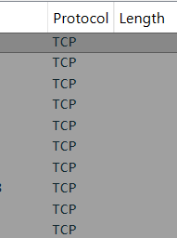

- Find the TCP packet with the maximum payload length.
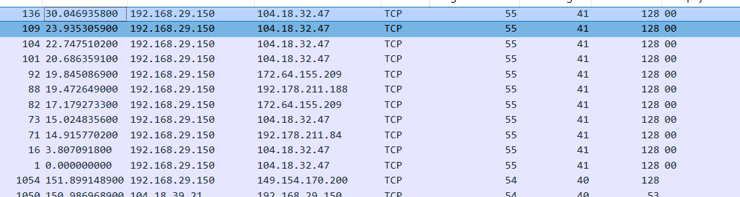

Task 5: UDP header inspection
- Apply the filter udp.
- Select five UDP packets and record:
  - Source port
  - Destination port
  - UDP length
  - Payload length
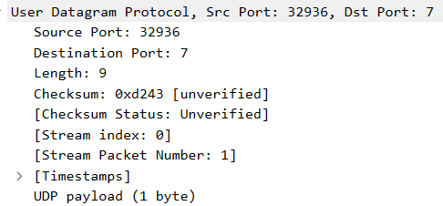
- Identify the UDP packet with the maximum payload length.
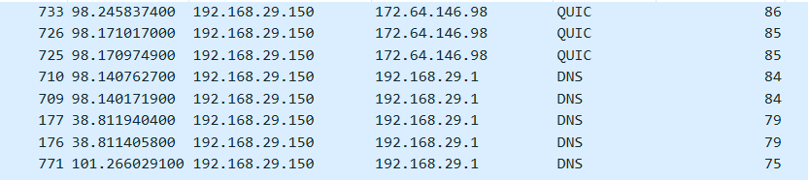

- Find the UDP packets carrying DNS traffic using the filter dns.

Task 6: Encapsulation and overhead calculation
- Select one TCP packet containing application data. Record the Ethernet, IPv4 and TCP header lengths.
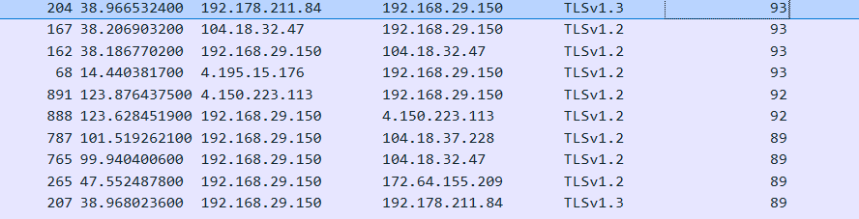

- Calculate the total protocol header overhead for the selected packet.

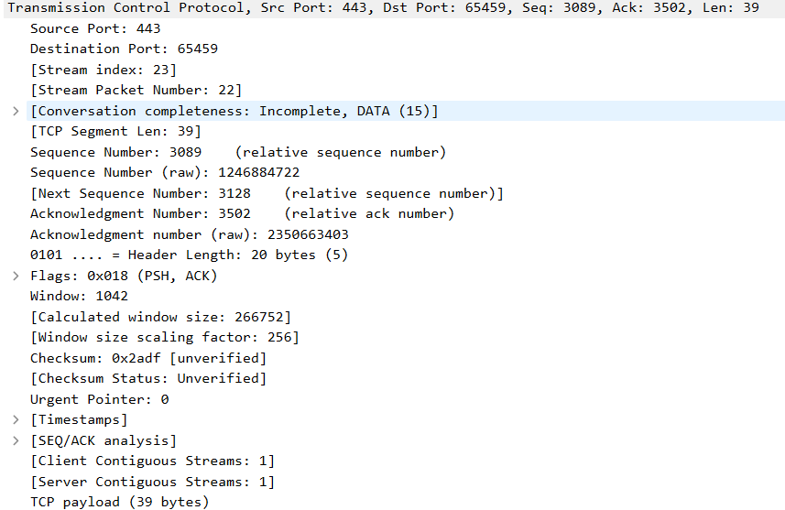
- Calculate the application payload size.
- Calculate the payload efficiency percentage.
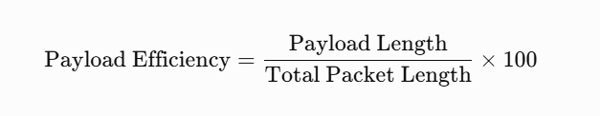

- Repeat the same calculations for one UDP packet.
- Compare the calculated overhead and payload efficiency of the selected TCP and UDP packets.

